1. From the home page of your SharePoint site, open a calendar you have created. In this example I will be opening **Team Calendar**.

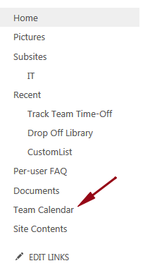

2. At the top of the page click **Calendar** to expand the ribbon.

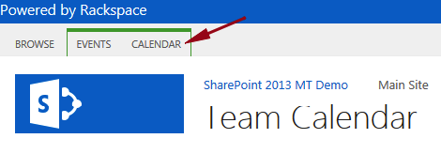

3. In the Manage Views section click **Calendars Overlay**.

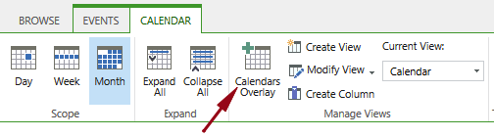

4. On the Calendar Overlay Settings page click **New Calendar**.

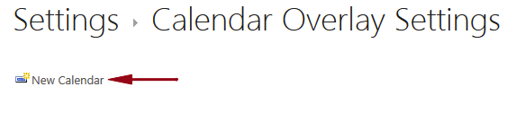

5. In the Name and Type section enter a name and select the type of calendar:

* + Calendar Name - **IT Calendar**
  + Type - **SharePoint** 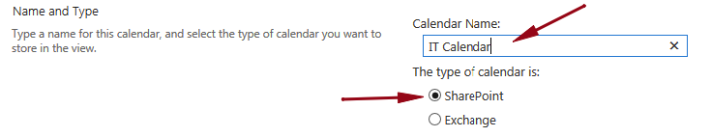

6. In the Calendar Overlay Settings section configure the following:

* + Description - **This is the team calendar from our IT Subsite**.
  + Color – **Red**
  + Web URL: For example, https://scuba3.atrackspace.com/IT) and click **Resolve**. (Navigate to the location of your other calendar)
  + List – **IT Calendar**
  + List View – **Calendar**
  + Always show – **unchecked**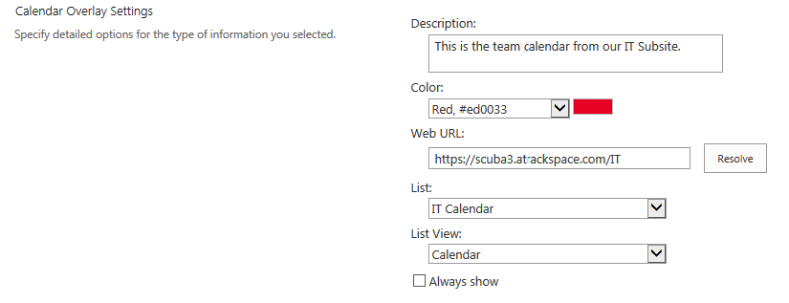

7. Review your settings and click **OK**.

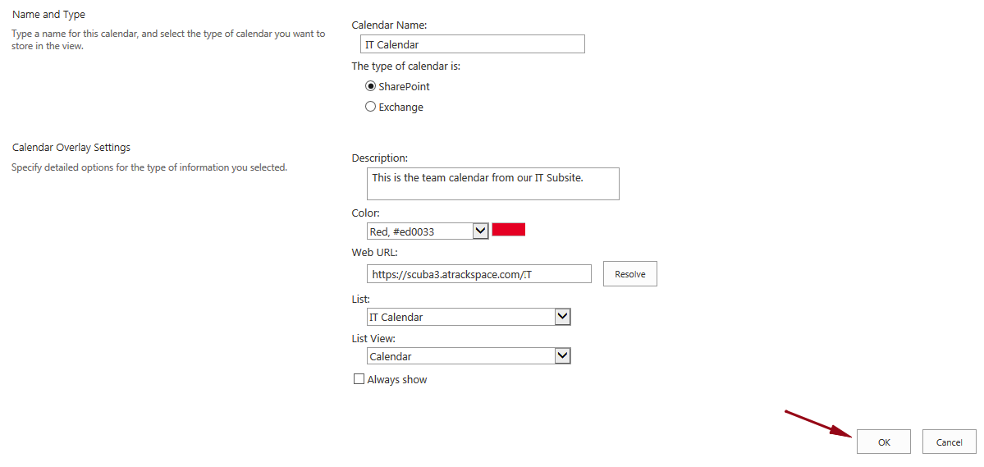

8. You will now see your calendar listed under Additional Calendars, IT Calendar.

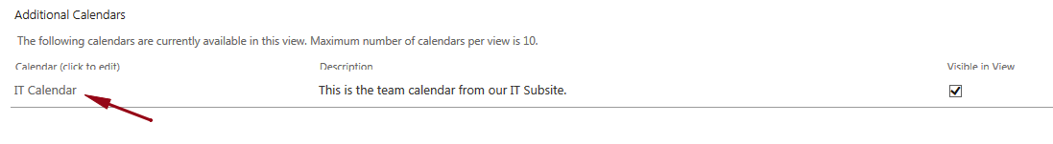

9. Click **OK**.

10. Back on our Team Calendar on the left hand side of the screen under Calendars in View you will see the calendar overlay you just created, IT Calendar.  
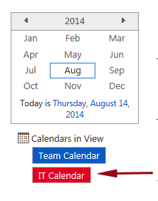  
  
11. You will also see all of the events from both calendars in one central location.

